Week 6 The Buggy Control Chip

Aim Write an Arduino sketch that checks all 9 buggy modes of operation, see attached sheet. Each mode of operation should be selected by sending an ASCII character over Xbee wireless link, eg ‘A’ for Normal line follow. The Arduino should be capable of receiving this character and outputting an appropriate pulse width to activate the buggy’s selected mode. See Figure 1. A bare bones sketch is available at W:\2E10\Week 6\BCC.ino. Please save this sketch as this code can be used to check a buggy not behaving as expected.

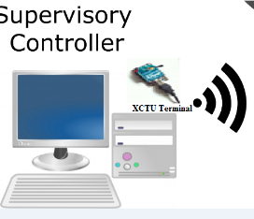 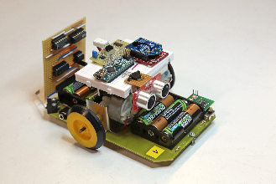

Figure 1

Using the PC Settings tab in the X-CTU program, select the virtual COM port with the circuit connected to it. This may need to be added using the user com ports tab.

The default settings are 9600, 8N1 and no flow control. Unless you have changed to another baud rate or configuration on the XBee that you are programming, these default settings should be fine. See Figure 2

Test communications by pressing the Test/Query button on the PC Settings panel.

Using the Modem Configuration tab in the X-CTU program, press the Read button to load the current configuration from your XBee radio. (If you would like to reset everything to the factory defaults, press the Show Defaults button.). Ensure that all settings match settings present in Arduino sketch, See Figure 3. Select a unique pan ID with matching settings in the Arduino Sketch. Use the X-CTU terminal to send characters to the buggy Arduino. Check operation of Buggy on track for all command modes.

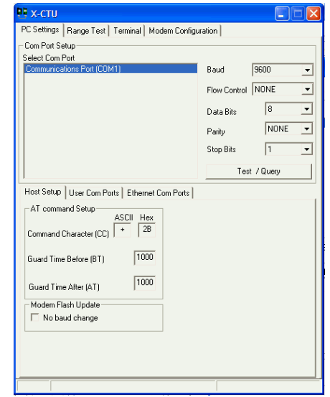

Figure 2

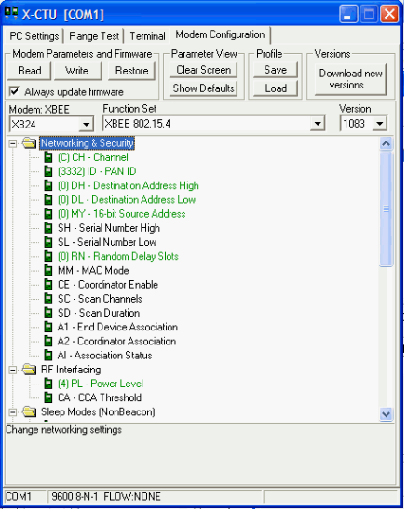

Figure 3

|  |  |
| --- | --- |
|  |  |
|  |  |